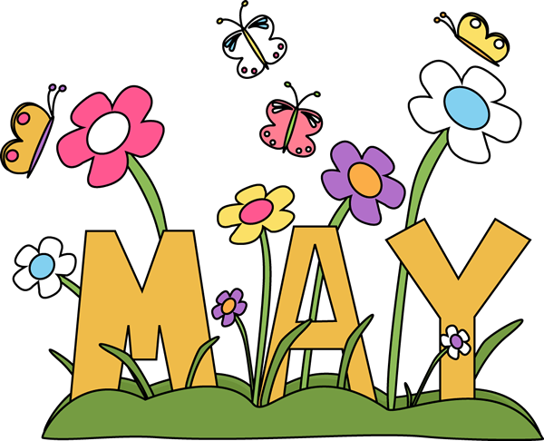

Hello everyone,

Spring is finally here.  I hope you are enjoying this beautiful weather with some new outdoor curriculum/activities.  With May upon us, we will have our last training for the fiscal year. This will be an at-home training.  I will send out an email with the CCEI instruction for the May 11th training. You can choose any training of your choice but you must submit your certificate dated for May 11th, so you can get credit for the training day.  Tina, Cathy and I will be available for assistance on this day.  If you have any other questions, please let me know.  
**If you applied for the grant and did not receive funding- do not be discouraged! There will be more opportunities to come.  
  
***Math activities can be taught in so many ways. Here’s a fun activity you can do with your kids. Who’s says teaching can't be fun?

Thank-You,

Marguerite Barbosa

Program Manager

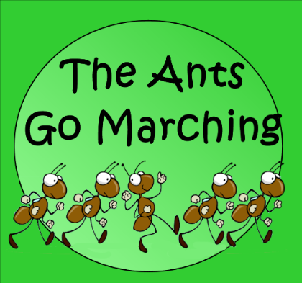Sing a song of math

“The ants go marching 2 by 2, hurrah,

hurrah…” Many children’s songs include

numbers, making them ideal for practicing

counting out loud. Try these musical

activities with your children.

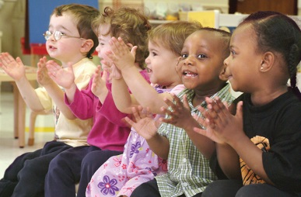 **Sing and clap**. Ask your child to choose a counting song like “The Ants Go Marching” or “Hickory Dickory Dock.” Whenever he sings a number, have him clap that many times. That means he gets to clap once after singing.

“The clock struck 1” and 12 times for “The clock struck 12.”

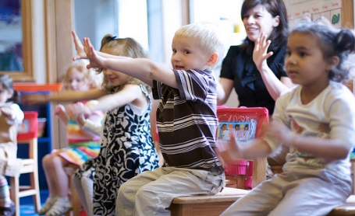 **Pick new numbers**. Substitute more challenging numbers for the ones in a song. Your youngster might sing “One Hundred Little Monkeys” instead of “Ten Little Monkeys” and count backward by 10s (“10 fell off and bumped their heads…90 little monkeys jumping on the bed”). Or name a random number to start with in a song like “This Old Man” so he can *count on* from numbers other than 1. (“This old man, he played 17…”)

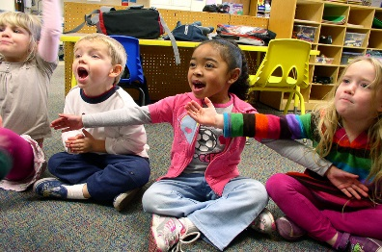 **Make your own.** Turn regular songs into counting songs by putting numbers into the lyrics. For example, the passenger’s in “The Wheels on the Bus” could count (“The people on the bus count 1, 2, 3…”) or skip count (“2, 4, 6…”).

© 2018 Resources for Educators, a division of CCH Incorporate

**Amy Vasconcellos,**

**Parent Intake Specialist**

**Commonwealth Family Childcare, Inc.**

**508-880-3556 ext. 16**

**Fax 508-821-4725**

** Emergency/Unexpected closures**:

Please remember when you have to close unexpectedly you must call the office and speak to someone. If it’s after hours, please leave a message on ext. 0 and then follow upwith an email to both Donna and me.  *If you are using a paid day you must state that in your email.*

*If you have any openings, please make sure you list them on the

templatewhen you send me your weekly attendance.  Also, please list

any part time openings*.  Knowing your availability is helpful when we*

*are trying to set up sub-care.*

*If you’ve already planned your summer vacations, please send me an email with the dates.  *It’s never too early to notify me!!!* Thank-you, Amy

|  |  |  |  |
| --- | --- | --- | --- |
|  |  |  |  |



Cathy Maltais

Family Child Care Support

Commonwealth Family Childcare, Inc.

508-880-3556 x14

|  |  |  |
| --- | --- | --- |
|  |  |  |

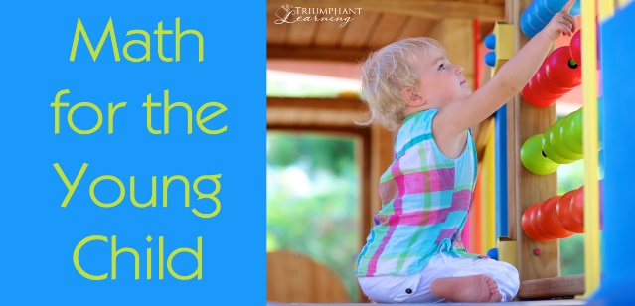

**Taken from Zero to Three**

Children are using early math skills throughout their daily routines and activities. For example, Thomas has two cars; Joseph wants one. After Thomas shares one, he sees that he has one car left (Bowman, Donovan, & Burns, 2001, p. 201). Other math skills are introduced through daily routines you share with your child—counting steps as you go up or down, for example. Informal activities like this one give children a jumpstart on the formal math instruction that starts in school.

**What You Can Do**

The tips below highlight ways that you can help your child learn early math skills by building on their natural curiosity and having fun together.

***Shape up*.** Play with shape-sorters. Talk with your child about each shape—count the sides, describe the colors. Make your own shapes by cutting large shapes out of colored construction paper. Ask your child to “hop on the circle” or “jump on the red shape.”

***Count and sort.*** Gather together a basket of small toys, shells, pebbles or buttons. Count them with your child. Sort them based on size, color, or what they do (i.e., all the cars in one pile, all the animals in another).

***What size is it?*** Notice the sizes of objects in the world around you: That pink pocketbook is the biggest. The blue pocketbook is the smallest. Ask your child to think about his own size relative to other objects (“Do you fit under the table? Under the chair?”).

***Picture time.*** Use an hourglass or timer to time short (1–3 minute) activities. This helps children develop a sense of time and to understand that some things take longer than others.

***Start today.*** Use a calendar to talk about the date, the day of the week, and the weather. Calendars reinforce counting, sequences, and patterns. Build logical thinking skills by talking about cold weather and asking your child: What do we wear when it’s cold? This encourages your child to make the link between cold weather and warm clothing.

***Big on blocks.*** Give your child the chance to play with wooden blocks, plastic interlocking blocks, empty boxes, milk cartons, etc. Stacking and manipulating these toys help children learn about shapes and the relationships between shapes (e.g., two triangles make a square). Nesting boxes and cups for younger children help them understand the relationship between different sized objects.

***Pattern play.*** Have fun with patterns by letting children arrange dry macaroni, chunky beads, different types of dry cereal, or pieces of paper in different patterns or designs. Supervise your child carefully during this activity to prevent choking and put away all items when you are done.

***Playground math.*** As your child plays, make comparisons based on height (high/low), position (over/under), or size (big/little).

***Graphing games.*** As your child nears three and beyond, make a chart where your child can put a sticker each time it rains or each time it is sunny. At the end of a week, you can estimate together which column has more or less stickers and count how many to be sure.

See many more ideas in the original article linked here.

<https://www.zerotothree.org/resources/299-help-your-child-develop-early-math-skills>

Sources for appropriate Math activities for young children.

Sesame Street Math <https://www.sesamestreet.org/toolkits/math>

NAEYC Math <https://www.naeyc.org/our-work/families/preschoolers-natural-mathematicians>

Math Milestones <http://www.pbs.org/parents/education/math/milestones/preschool-kindergarten/>

**Catherine Maltais Tina Slavick**

**Family Childcare Support Specialist Educator Support Specialist**

**X14 X19**

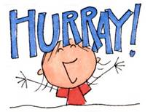

**April’s Newsletter Riddle Winner was**

**Margie Walder owner of “Kids Count” Dartmouth, Ma.**

**The answer was; an eraser**

**Margie won the set of 360 drinking cups** 

****Can You answer this month’s riddle? 

*“A package without key, hinges or lid, yet golden treasure inside is hid.”*

The First one to respond with the correct answer wins a gardening activity kit!

**contributed by; Carolyn Mulhern**

**Social Services Coordinator**

**ext. #17**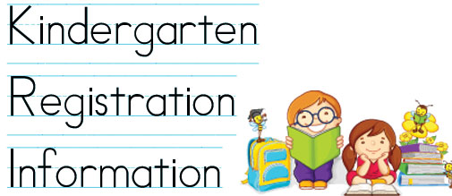 Kindergarten Registration is well underway for the 2018-2019 School Year. Please check with your families and share this information if needed to register their child for Kindergarten.

**Taunton Public Schools – 5 years old on or before August 31, 2013**

**http://www.tauntonschools.org/uploads/1/6/5/4/16543006/kindergarten_registration_flyer_2018.pdf**

**Bennett Elementary School** 47 North Walker Street, Taunton

May 1, 2018 6:00 p.m. - 7:00 p.m.

**Hopewell Elementary School** 16 Monroe Street, Taunton

April 11 - May 01 9:30 a.m. - 1:30 p.m.

May 01, 2018 5:00 p.m. - 6:00 p.m.

**Elizabeth Pole Elementary School** 215 Harris Street, Taunton

April 11 - May 3 9:30 a.m. - 1:30 p.m.

May 3, 2018 5:30 p.m. - 6:30 p.m.

**East Taunton Elementary School** 58R Stevens Street, E. Taunton

April 11 - May 7 9:30 a.m. - 1:30 p.m.

May 7, 2018 6:00 p.m. - 7:00 p.m.

**Chamberlain Elementary** 480 Norton Avenue, Taunton

May 8, 2018 5:00 p.m. - 6:00 p.m.

*If you are in one of the school districts below please call the school*

**Mulcahey Elementary School** 28 Clifford Street, Taunton/ 508) 821-1255

**Galligan Elementary School** 15 Sheridan Street, Taunton/ 508) 821

**\*Brockton Public Schools - Any Brockton resident child born January 1 - October 31, 2013 (Brockton has changed their age cutoff date from Dec. to Oct. 31, 2018)**

**https://www.brocktonpublicschools.com/parents-community/registration-student-assignment/kindergarten-registration**

Open Enrollment April 23 – May 11, 2018

Monday – Friday 8:30a.m. – 2:30 p.m.

Wednesday 5:00-7:00 p.m.

**Last registration ½ hour before closing time**

**Walk ins Welcome or call to schedule an appointment**

60 Crescent Street

Brockton MA 02780

508-580-7950

**New Bedford Public School – 5 years old before August 31, 2018**

**http://www.newbedfordschools.org/cms/one.aspx?portalId=67022&pageId=154355**

The Family Welcome Center is located at 455 County St., Room 105, New Bedford. For more information and to register children for school please call 508-997-4511, ext. 3424 or 3275. Families are welcomed between 8:00 a.m. to 4:00 p.m., Monday through Friday, with the exception of school holidays.

**Tina Slavick**

Educator Support Specialist

***How Children Develop Empathy***

Empathy is a skill ― one that we can strengthen with practice. Empathy means that we can imagine what someone else is thinking or feeling and then respond in a caring manner. At two years of age, kids are slowly starting to understand that other people have thoughts and feelings that are different from their own. For example, they might discover that they prefer chocolate ice cream but their sister prefers vanilla. At two they begin to notice and name when other people are happy, mad or sad; and you might see a child offer a toy or hug to a crying friend.

***How to teach Empathy***

Model empathy by reflecting children's emotions and responding with compassion. For example, you might say, "You jumped when you heard that thunder. Thunder won't hurt you, but it can sound scary! Do you want to sit on my lap for a while?"

Reading fiction promotes empathy. Picture books are an ideal way to both expose children to diverse cultures and talk with them about struggles people face locally and globally. As you read ask, "How do you think she feels right now?" or "What do you think he needs?" Below are some titles you find at your local library or Amazon.

           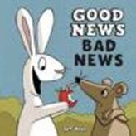        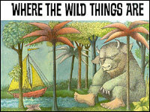

During dramatic play children take on different imaginary roles, from parent to superhero to a favorite story character.  They quite literally practice putting themselves in someone else’s shoes.  Dress up clothes, dolls and stuffed animals can be tools to engage in dramatic play.

According to research, when caregivers talk about how they are thinking and feeling, it helps children's "theory of mind" development. In other words, it shows them that you have distinct feelings that may be different from theirs in a given moment. During the course of a day, try saying, "Right now I feel happy because . . ." or "I feel frustrated because . . ." or "Right now I am thinking about . . . and that makes me feel . . ."

Information provided by **© PBS 20**

Contributed by; Catherine Maltais

Family Child Care Support Specialist

x14

 EEC Regulations (laws) require curriculum to be developmentally appropriate and individualized. s*ee below*

When planning for the children’s experiences please refer to scientifically backed, vetted, professional resources.

Mass Guidelines for Preschool Learning Experiences

Mass Early Learning Guidelines for Infants & Toddlers

National Association for the Education of Young Children <https://www.naeyc.org/resources>

Creative Curriculum for Family Child Care

Zero to Three <https://www.zerotothree.org/early-learning>

PBS Parents <http://www.pbs.org/parents/education/>

Center for Disease Control <https://www.cdc.gov/ncbddd/childdevelopment/index.html>

Pinterest can be a good resource for decorating, but it is not a reliable curriculum resource.

7.06: Curriculum and Progress Reports

**(1) Curriculum.**

(a) The licensee must provide a well-balanced curriculum. of specific, planned learning experiences that support the social, emotional, physical, intellectual and language development of all children. The curriculum must:

1. be developmentally and linguistically appropriate;
2. provide for the development, interests and temperaments of individual children;
3. support school readiness and/or educational development; and
4. include goals for the knowledge and skills to be acquired by children in the areas of English language arts, mathematics, science and technology/engineering, history and social science, comprehensive health, and the arts.

Contributed by; Janet Bruce

Social Services Case Manager

**May is National Family Month - a great time to celebrate the importance of family and an opportunity to spend time together.**

***Let’s focus on meaningful ways to celebrate holidays without spending money. Families may find certain holidays stressful due to the amount of commercialization and the media pressure to buy gifts. Educators can help by showing children that handmade gifts are very special and celebrating can be joyful in several different ways.*** ***Those special songs, Mother’s Day activities of poems or gifts made by a preschooler and given to Mommy, Grandma, Auntie or other caring women are priceless!***

**

It was in 1914 when Woodrow Wilson signed a proclamation recognizing the second Sunday in May as Mother's Day.

Mother's Day is a day dedicated to honoring and recognizing the sacrifices, love and accomplishments of mothers.  Mothers are recognized by family and friends; regardless of whether they are biological or perceived maternal figures.  It is a day to honor and respect mothers; a day to show them how important they are to us.

As we celebrate Mothers, please remember that this day may be difficult for some children. Do any of your children have a mother deployed in the military? A mother who has passed away? No mother in their home? Two mothers in their lives? It is important for us, as educators, to be aware of and be sensitive to these situations. Example:  You might make 2 gifts for children with a biological and a foster mother

We can teach our children songs to praise their moms!

**Tune: *The More We Get Together***

I really love my Mommy, my Mommy, my Mommy,  
 I really love my Mommy, I love her so much.  
 She feeds me and dresses me, she hugs me and kisses me -    
 I really love my Mommy, I love her so much!

**Tune:** ***This Old Man*** **Tune:** ***Happy Birthday***  
Mother's Day, Happy Mother’s Day to you.  
Mother's Day, Happy Mother’s Day to you.   
Is a very special day. Happy Mother’s Day Dear Mommy,   
Here's a great big hug Happy Mother’s Day to you.  
And lots of kisses too.  
Each one says that I love you!

**Tune:** ***Five flower baskets sitting on the floor.***  
 One will go to _____'s mom, then there will be four.  
 Four flower baskets, pretty as can be.  
 One will go to _____ 's mom, then there will be three.  
 Three flower baskets with flowers red and blue.  
 One will go to ______'s mom, then there will be two.  
 Two flower baskets, bright as the sun.  
 One will go to ______'s mom, then there will be one.  
 One flower basket, where’s it going to go?  
 To my very own mommy, who is the nicest one I

Fun activities make awesome gifts

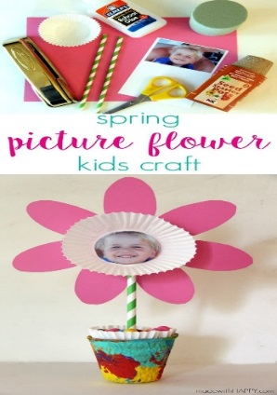 Simple Supplies can be found at your local dollar store!

piece of colored paper (8.5″ x 11″)

2 muffin wrappers

1 green paper straw

white glue

a small piece of floral foam

small pot (I used seed started pots)

1 picture of cute kid

scissors

stapler

colorful candy, marbles, rocks – anything to give the pot a little weight

paints (optional) to paint the pots

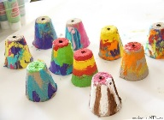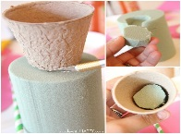 .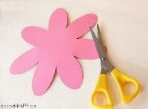  .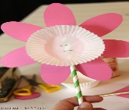

**Directions: Can be found;** [**https://madewithhappy.com/**](https://madewithhappy.com/)

***Let the children design 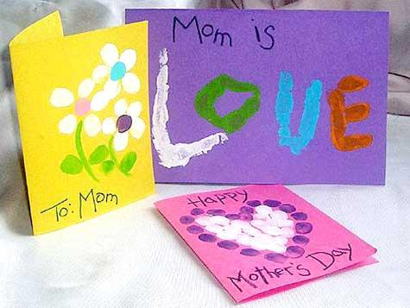 a card for mom and then transcribe the “child’s words” for mom.***

**My name is _________________________.**

**I am ______years old.**

**My mom’s name is _______________________.**

**Some people call her _______________________.**

**She is ______ years old.**

**She loves to______________________, but she doesn’t like to _________________________.**

**She is good at ___________________________________.**

**I like it when she _____________________________________.**

**My mom and I both enjoy __________________________.**

**I love my mom because ____________________________.**

**She is special because _____________________________.**

**I Love You Mom,**