Hello Educators,
I want to thank everyone who attended our Professional Development Day. I enjoyed seeing everyone and feel that it was an excellent networking opportunity. The feedback on the evaluations indicates that everyone felt that the training was informative and enjoyable. The training certificates are in your mailbox and will be delivered by your Support Specialist.
I know working with different age groups can be challenging and rewarding at the same time. I have attached an article I found about caring for mixed age groups that you may find beneficial.
Marguerite Barbosa
Program Manager

Caring for Mixed Age Groups

Karina is not unlike many other family child care providers. She opens her home to care for four other children in addition to her own four-year-old son. She cares for a young infant and his two-year-old sister full time. She welcomes a three-year-old on Tuesday and Friday and eight-year-old Jalika joins the group every afternoon after school. Unlike child care center teachers, family child care providers often care for children of many ages. Family child care providers may offer services for children as young as six weeks of age and many provide afterschool or summer care for older children as well. Caring for a mixed age group presents a unique set of challenges and benefits for the caregiver.

Challenges
- The caregiver must take extra safety precautions when there are infants or toddlers in care.
- It may be difficult to find snack items that are appropriate for all age groups.
- Planning structured activities is difficult when there are children with various ability levels and interests.
- Daily routines such as nap or meal times may need to be more flexible to accommodate different aged children.
- Older children may prefer same age peers and resent the younger child in a play group.

Benefits
- Multi-age groups offer children opportunities to develop and practice social skills.
- There is a wider range of behavior and performance that is likely to be accepted and tolerated by the adults as well as by the children themselves.
- There are often less competitive and more cooperative or helpful behaviors.
- Mixed-age group care is more like a home setting and often a more comfortable and secure setting for young children.
- Siblings are not separated.
- By design, mixed-age group care is geared more to the needs of individuals. Children in such groups have greater freedom to develop at their own rate.
- Older children learn to adapt their language and social skills to relate with younger children, often learning patience, compassion and problem-solving skills.
- Younger children are challenged by older children and often engage in more complex activities then when they play with same age peers.

Tips for caring for mixed-age groups
- Provide a wide range of choices. Most caregivers find that most of the day is comprised of unstructured "free play" where they provide a wide range of materials and activities that are appropriate for various children.
- Provide some materials that are used specifically for an age group. Not all toys or areas need to be "one size fits all." It is fine to have some toys that are of specific interest for only one age group.
- Consider ages of children when you set up the child care space. Safety is paramount. Scissors that are used by school-aged children may need to be stored out of the reach of toddlers. Materials that are safe and appropriate for younger children can be arranged in easy to reach bins or containers. You may want to provide smaller sized furniture and step stools for younger children too.
- Select toys and materials that are open ended and can be used in many ways. Balls, art materials, blocks can be used by children with various abilities; they will use the material in increasingly complex ways.
- Focus on individual or small group activities. Asking a group of children of differing ages to participate together may bore older children or frustrate younger children.
- Use the opportunities to promote cooperation and team work. Encourage children to help each other and solve problems together.
- Accept the fact you may need to be flexible when scheduling daily routines. Meeting the needs of individual children may mean you need to veer from routine. You may find a need to prepare an extra snack for an afterschool child or set up a quiet area for the youngster who still needs a nap.

http://www.childcarelounge.com/family-child-care/caring-mixed-ages.php

Regulation Reminder
Contributed by: Catherine Maltais
Educator Support Specialist

7.05 Interactions Among Adults and Children

(8) The following practices are strictly prohibited:

(a) spanking or other corporal punishment of children;

(b) subjecting children to cruel or severe punishment such as humiliation, verbal or physical abuse, neglect, or abusive treatment including any type of physical hitting inflicted in any manner upon the body, shaking, threats, or derogatory remarks;

(c) depriving children of outdoor time, meals or snacks; force feeding children or otherwise making them eat against their will, or in any way using food as a consequence;

(d) disciplining a child for soiling, wetting, or not using the toilet; forcing a child to remain in soiled clothing or to remain on the toilet, or using any other unusual or excessive practices for toileting;

(e) confining a child to a swing, high chair, crib, playpen or any other piece of equipment for an extended period of time in lieu of supervision; and

(f) excessive time-out. Time-out may not exceed one minute for each year of the child's age and must take place within an educator's view.

Amy’s Corner,

When you are completing your attendance, please remember to list any
sub-care that you did on the section of the attendance template that is
designated for sub-care.

*Many FCC Educators who contract with CFC, Inc. agree to provide
substitute care when a child’s regular Educator is unavailable. FCC
Educators who care for children on a substitute basis must have on
file current EEC enrollment forms. Both parents and Educators receive
blank EEC approved forms in their guide books, or Educators can go to
the EEC website for enrollment forms. All attendance invoices must
also include the days that Educators offer alternate care.

December was a very busy month for sub-care. A big thank you to
all of the Educators who helped out!!! We greatly appreciate it!!

Amy Vasconcellos,
Parent Intake Specialist

Gross motor fun when there is no sun
Winter weather can keep you inside. The yard is a soggy mess, the cold wind makes your face feel like it will fall off. You need things for your learners to get those wiggles out, or you’re going to go a little crazy! Here are 10 gross motor activities to do just that. You can find more activities on the Measured Mom website. https://www.themeasuredmom.com/indoor-gross-motor-activities
1 – Toss bean bags into baskets
Provide laundry baskets. Then get your learners in several rows, and have them take turns tossing bean bags into the target.
2 – Move on paper plates
Buy some colored paper plates. Then get creative! Place them in a row (red, green, red, green) and have students step on just the red ones. Or have them get down on all fours and “skate” with a plate under each hand. Put the plates in a row to get your students moving around the classroom. Put the plates far apart for big steps. Or put them close together for tiny steps.
3 – Learn with a ball toss
If your learners are able to catch a simple toss, put them in a circle. Then think of a way to incorporate learning with a ball toss. For example, you can throw a ball to a student and name a word. Then s/he names a rhyming word and tosses the ball back to you. Toss it to another student with a new word for him/her to rhyme.
4 – Play “find and tag it”
This is a versatile game that can be used to review many different skills. Just tell your learners to find something and tag it. For example, “Find and tag something blue.” Or “Find and tag something that starts with /s/.”
5 – Move like an animal
You’ll need some open space, but this is a great way to get kids using new muscles. Here are some ideas:
- Move like a bird (run with arms outstretched)
- Move like a snake (wiggle on tummies on the floor)
- Move like a bear (walk on all fours)
- Move like a frog (get down on haunches and hop)
- Move like a kangaroo (take big leaps with arms in front of chest)
- Move like a penguin (waddle with ankles close together and arms pinned to sides)

6 – Have fun with painter’s tape
Painter’s tape is one of the best inventions ever. It goes on (and comes off) easily – whether you’ve got a smooth floor or a carpeted one (but be sure to test it first just to be sure). And there’s so much you can do with it! Put it on the floor like a ladder. Then have students see how many rungs they can jump. Can they jump farther with a running start? See how many rungs they can stretch – or how far they can go on one foot.
7 – Copy me!
This is where you can get in your workout for the day. Simply do a series of exercises or silly actions, and have your students copy you. Jump like a kangaroo. Scratch like a monkey. Run in a place. (Whatever it takes to get that heart rate up!)
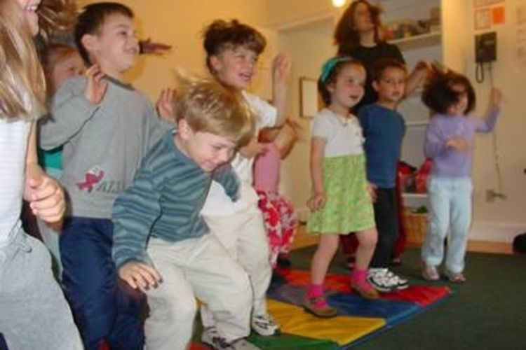
8 - Create a wiggle jar
Print action cards and place them in jar. When your students need a movement break, pull a few cards for everyone to do. Here are some ideas for a preschool wiggle jar:
- Jog in place while you sing the alphabet.
- Touch the sky and then your feet five times in a row.
- Pretend you’re playing the drums.
- Fly around the room like a bird.
10 – Tape balance beam
This is a simple, but surprisingly fun! Grab several rolls of colorful painter’s tape, and set it on the floor in different lines; make the lines zigzag, curvy, straight, or shaped like a circle, square, or other shape. Then challenge your learners to walk each colored line from beginning to end

Contributed by, Tina Slavick
Educator Support Specialist

Contributed By: Cathy Maltais
The value of “Time Out” has been debated over the years, but current thinking is that the use of time out on a regular basis is not as effective as other approaches in most circumstances. I personally have always felt that the use of time out is only appropriate if not used as punishment. Child Specialists and Psychologists agree that the use of punishment as a deterrent to negative behavior is not effective, and can have negative impacts on the child’s self-esteem.
The only time that I advocate for “Time Out” is when it is used as a break from the pressures of the group. It truly should be used as a reflective time. Super Nanny may look like she’s solving the problems of many families, but I cringe every time she uses the phrase “naughty chair”. In truth, the phrases that are most appropriate are “let’s take a break”, “please think about how we should treat our friends for a few minutes”, “I would like you to look at books for two minutes before you go back to play”, “I can’t let you hurt your friends, so let’s sit here quietly on the cushions for a few minutes”.
Ideally, Providers should have a feel for their group, try to sense when behaviors are escalating, and find steps to head off trouble. That could prompt a sudden shift in the flow of activities. “Let’s clean up now; and go outside early!”; “I think it might be time for snack now, let’s see how quickly we can clean up”; “FREEZE! I’m feeling a song coming on – come on over and sing with me!” One of the easiest approaches is focused attention on the child who is on the verge of trouble: one on one time – even for just 2-3 minutes, or re-direction, “come show me how tall you can build with these blocks”.
One of my personal pet peeves is when we as Educators say “no” too often. Children need options. The urges that they face as little people are just too strong, and they are still learning to control them. When we constantly tell them “no”, we are creating volcanoes that will erupt, rather than teaching them self-control through small steps. Instead of telling them that they can’t throw toys, give them toys that they can throw, such as koosh balls and bean bags. Instead of telling them that they can’t run, allow them to dance, or let them know how soon you will be taking them out so that they can run. We can’t allow them to bite their friends, but give them a teething ring that they can bite.
At the end of the day, please keep in mind that these young children are looking to you for guidance and instruction. While it may not seem that society values your chosen profession, it is one of the most important jobs on the planet. Teach your children well. – Robin-
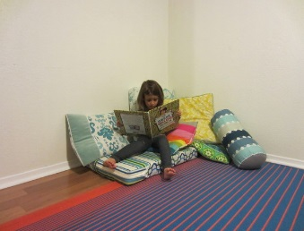
On Line Resources
https://www.parents.com/toddlers-preschoolers/discipline/time-out/why-time-out-is-out/http://www.ahaparenting.com/parenting-tools/positive-discipline/timeouts

Interviewing Child Care Families
Contributed by: Carolyn Mulhern, Social Services Coordinator
Janet Bruce, Social Services Case Manager
Interviewing new families can be a challenging part of operating a Family Child Care program. Many Educators don’t know where to start. It can be intimidating to invite someone you don’t know into your home, answer all of their the questions , and make sure that you ask all the right questions to see if their needs are ones your program can service. Plus, it can feel as though your whole life and family are on display for evaluation and judgment by people who are essentially strangers. This sometimes makes Educators nervous and at times can feel like you can’t be yourself, even when it is your home, business, and everyday life that in which they will be part.
Let us share a few tips for a successful interview:

- Introduce yourself, your assistant and ANYONE else who is present at the interview. Examples: Early Intervention Specialist, staff from CFC, Inc. other parents dropping off their child, your EEC licensor, or even a family member walking out the door to leave for work.

- Have an activity planned for the children enrolled in your program and the prospective child. This gives you the opportunity to speak with the family that is interviewing your program, with little distraction.

- Show the family your space, including your outside play area. Let them know what areas in your home are included on your license. Be specific on what areas are used for feeding, activities, diaper changing, toileting, washing hands, nap time and outside play.

- GIVE THE FAMILY YOUR HANDBOOK WITH YOUR CONTACT INFORMATION.

- Allow older children in your program to tell potential families what their day entails. They sometimes can describe the child care routine better than you!!

- Discuss your hours and the supplies that they will need to provide for their child.

- Ask the family about their child and previous child care experiences. What is the child’s likes and dislikes with food, toys and activities? Do they nap? Explain the EEC regs. on safe sleep, napping and rest time.

- Remember to respect the confidentiality of the children enrolled in your program. Refrain from discussing where a child lives, their parents/family name, the child’s behavior, or if they are involved with outside services, such as Early Intervention.

Just a few of the days/events that you may want to observe or celebrate this month

Black History Month National Wild Bird Feeding Month
February 15-Susan B. Anthony Day
February 16-Chinese New Year
February 17-Random Acts of Kindness Day
February 19-President’s Day
February 26- Tell a Fairy Tale Day

